**Executive Tours South Island**

**Private Tours**

4 nights 5 Day **Scenic** South Island tours

**Christchurch > Franz Josef > Wanaka > Twizel > Aoraki Mount Cook > Lake Tekapo > Christchurch**

**Tour map of visiting locations.**

Starting in Christchurch city at 09:00.

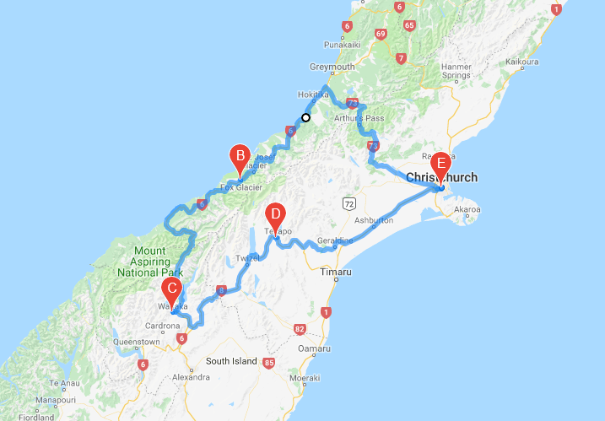

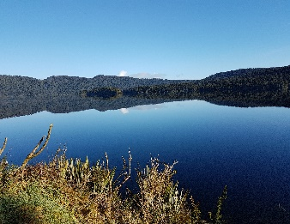

**DAY ONE:**

Heading to the Main divide mountain range, stopping for mountain views, Rock formations Castle rock, Arthur’s Pass see the mountain parrot the Kia, waterfalls, Hokitika township on our way to Franz Josef for our first night.

Incredable lake views before we reach Franz Josef, with plentry of photo stopping opportunitites.

Travelling from one side of the island to the other.

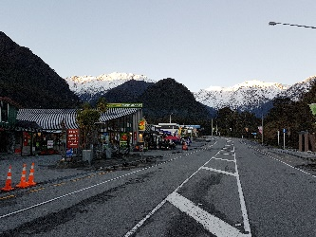

**DAY TWO:** Lake Wanaka.

This amazing journey down the West Coast of New Zealand is a spectacular journey with around every corning there are incredible mountain views.

It will take about 6 hours to Wanaka with stops on the way. Maybe we stop for a later lunch as there are fewer options on this road. Lats take the high road over the crown range into Arrowtown.

Leaving Lake Wanaka, the next morning about 9am over the Lindis pass.

**DAY ONE**:

Franz Josef township. 1 nights stay.

Opportunity to take the Franz Josef Glacier walk/ Helicopter scenic ride or the Heli Hiking.

Local craft and souvenir stores welcome you. Clean fresh air . The next day journey over the Haast pass.

Leaving Franz Josef around 9am with travelling time to Queenstown via Wanaka and over the crown range.

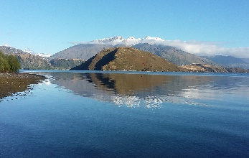

**DAY TWO:** Queenstown 2 nights.

This amazing journey down the West Coast of New Zealand is a spectacular journey with around every corning there are incredible mountain views.

It will take about 6 hours to Wanaka with stops on the way. Maybe we stop for a later lunch as there are fewer options on this road. Let’s take the high road over the crown range into Arrowtown.

Leaving Lake Wanaka, the next morning about 9am over the Lindis pass.

While in Queenstown we have options to a multitude of activities:

Bungy Jump, Gondola ride, Sky dive inside, King Pin bowling, Jet boat ride, TSS Earns law steamboat and BBQ Day tip, or a trip to Arrowtown. We could book you the day trip to Milford Sounds and the cruise out to Milford. Activities and food and beverage not included in our prices.

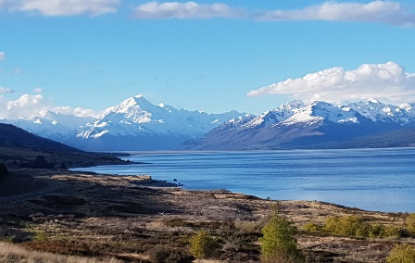

**DAY FOUR**: Aoraki Mount Cook. 1 night

Aoraki or Lake Tekapo. Stay one night. Viewing the clear turquoise Lakes first Pukaki then Tekapo. We stop at the top of lake Pukaki to buy some freshly farmed Salon. When at Lake Tekapo take the Dark skies, star gazing tour to the top of the observatory. Sit back at the hot pools of the mountains while sitting back and relaxing during the day or night.

Leaving Mount Cook about 10am or Lake Tekapo at 11am for Christchurch city.

Day Five: Final day:

Lake Tekapo is an amazing location with the lake colours and the history about the location. Sit back and let your guide take you to some amazing location.

**What we provide:**

* Personal chauffeur private tour
* Local business local driver/guide
* Personal service to meet your requirements.
* Comfortable European vehicles.
* Vehicle/fuel/ vehicle insurance/driver-guide.
* NZ government tax of 15%

**What you must provide:**

* Accommodation: As everyone has their own accommodations and meals requirements, we provide the location we are staying in, and you choose your own accommodation and restaurants, or we can assist you with this. Try Booking.com or Trivago for suggestions but please check with us to confirm you are staying in a proximity to our location:
* Meals:
* Personal travel insurance:
* All other personal belonging:
* Activities are not included in our pricing, but we can arrange these for you.

Our Chauffeured tours are private with groups from one up to 11 guests and designed for the scenery and or adventure in you. Ideal for family groups only as we do not operate as a bus company mixing up our passengers.

As a bespoke tour chauffeur service, we can adapt your requirements. Our pricing includes New Zealand Government tax of 15%.

Our tours are charged as **per vehicle** with the luggage capacity to suit the vehicle size.